-------------------------------------------------------------------------------------------------------------------------------NAME: ARCHANA DEVI.P
REG NO: 192521192
COURSE: SOFTWARE TESTING
CODE: CSA0923
LAB PROGRAMS
27. Calculate the Average of N Numbers Using Functions
Aim
To write a Java program to calculate the average of \(N\) numbers using functions and verify the output using white-box testing.
Algorithm
- Start.
- Read the numbers into an array.
- Pass the array to the average-calculation function.
- Calculate the sum of all elements.
- Divide the sum by the number of elements.
- Return the average.
- Test the function with different inputs.
- Stop.
Program: AverageNumbers.java
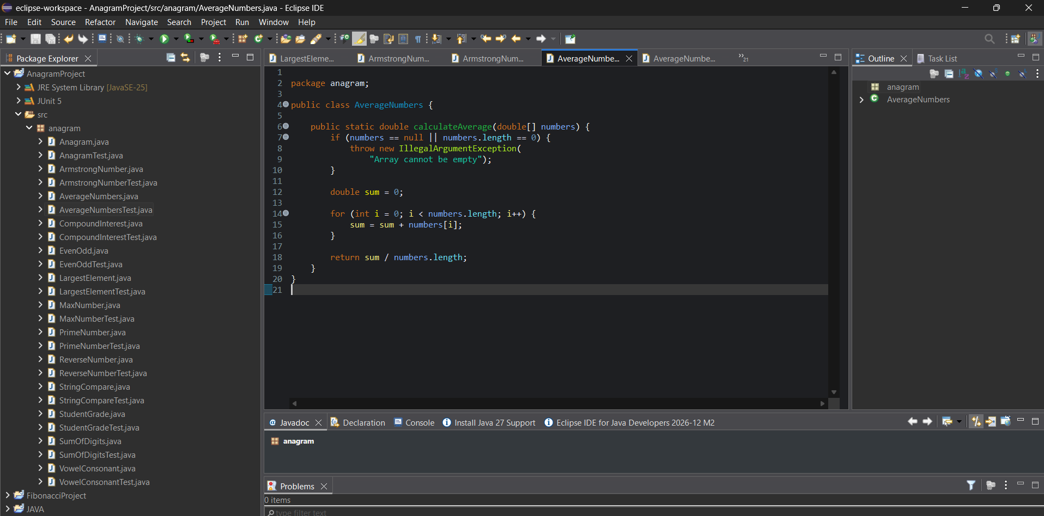
JUnit Test Case: AverageNumbersTest.java
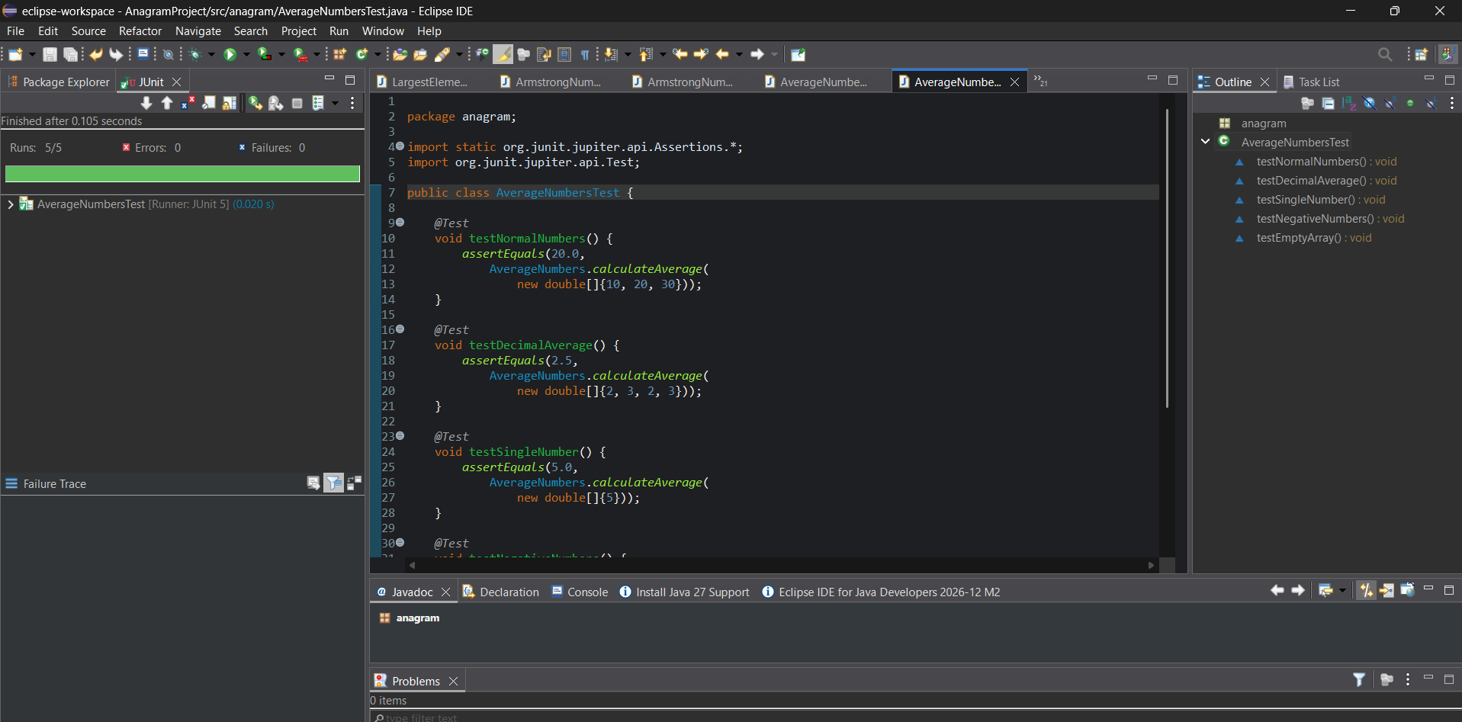
White-Box Testing
- Check the loop when it executes and when it is skipped for a single-element array.
- Check that every number is added to the sum.
- Check the division by the number of elements.
- Test normal, decimal, negative, and empty inputs.
Result
The Java program to calculate the average of N numbers using a function was implemented successfully. The output can be verified using JUnit assertions and white-box testing.

